THE SWORD IN THE TREE  Lord Weldon’s brother appears from nowhere. Then Lord Weldon disappears and his son Shan and his wife, Lady Marian are in danger. While seeking shelter with a herdsman, Shan learns that King Arthur holds audiences and appeals to the King. Sir Gareth challenges Lionel to a duel and restores Castle Weldon to Shan and his Mother. Who do you suppose they find in the dungeon? | 1997 | 64 p.

 | Duey, Kathleen | LARA AND THE GRAY MARE  Hoofbeats Book 1  While her father is away fighting the Normans and other Irish clans, nine-year-old Lara works hard to help harvest food and also cares for the pregnant gray mare that she loves. | 2005 | 140 p.

 | Duey, Kathleen | LARA AND THE MOON-COLORED FILLY  Hoofbeats Book 2  Captured by members of another Irish clan, Lara continues to protect the young filly, Dannsair, and ponders how they might escape together. | 2005 | 133 p.

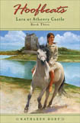 | Duey, Kathleen | LARA AT ATHENRY CASTLE  Hoofbeats Book 3  When her horse is given to a baron in the castle town of Athenry, nine-year-old Lara goes along. | 2005 | 140 p.

 | Duey, Kathleen | LARA AND THE SILENT PLACE  Hoofbeats Book 4  Almost a year has passed since Lara and her beloved filly were captured and taken from their Connemara home. The duo endured many long months of lying, hiding, and struggling to survive. At last, Lara has finally managed to escape with the filly, Dannsair, and make her way back home. But rather than feeling relief at being back with her tauth, Lara is overcome with feelings of not belonging. She craves something more than her old life can offer her. her heart wonders if there is a place where she and Dannsair can be happy together-and safe from the warring clans. | 2005 | 140 p.

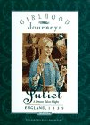 | Kirwan, Anna | Juliet : Midsummer at Greenchapel, England, 1340  Girlhood Journeys series  On the day before Midsummer Eve in Greenchapel, England in 1340, 11-year-old Juliet accompanies Gil on a trip to get medicine for a wounded falcon while hoping to arrive home on time for the fun. | 1997 | 64 p.

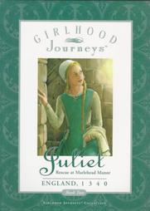 | Kirwan, Anna | Juliet: Rescue at Marlehead Manor  Girlhood Journeys volume 2  In England in 1340, Juliet resents Marguerite's snooty new friend Lady Enid, but when she learns that Enid's father has been unjustly accused of treason she volunteers for a dangerous mission to help clear his name. | 1997 | 71 p.

 | MacGill-Callahan, Sheila | TO CAPTURE THE WIND  In a risky plan to free her kidnapped lover, Oonagh cleverly solves the evil pirate king's riddles, unites the princess Ethne with her lover, and invents sails. | 1997 | unpaged

 | O'Brien, Patrick | THE MAKING OF A KNIGHT:  HOW SIR JAMES EARNED HIS ARMOR  Traces James’s journey during the Middle Ages in England from an inexperienced page at the age of seven to knighthood at the age of 21. | 1998 | unpaged

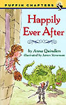 | Quindlen, Anna | HAPPILY EVER AFTER  When a girl who loves to read fairy tales is transported back to medieval times, she finds that the life of a princess in a castle is less fun than she imagined. | 1997 | 43 p.

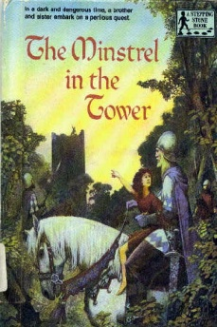 | Skyrzynski, Gloria | THE MINSTREL IN THE TOWER  1195. Roger and Alice have lost their father to the Crusades. Now their mother is terribly ill. They set off in search of their mother's long-lost brother, a powerful baron. Their night in a tower is interrupted by two highwaymen, who imprison them and recognize the symbol on the lute they carry, their only identification that their uncle, Raimond, will recognize. | 1988 | 64 p.

5th Grade and UP
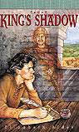 | Adler, Elizabeth | KING'S SHADOW  After he is orphaned and has his tongue cut out in a clash with the sons of a Welsh noble, Evyn is sold as a slave and serves many masters, from the gracious Lady Swan Neck to the valiant Harold Godwinson, England's last Saxon king. 1063 | 1997 | 259 p.

 | Amoss, Berthe | LOST MAGIC  Orphaned Ceridwen learns the art of herbal healing and gains the protection of the local lord until she is accused of witchcraft. | 1993 | 184 p.

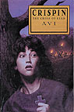 | Avi | CRISPIN: THE CROSS OF LEAD  When his mother dies, a fourteenth-century peasant boy must flee for his life after being accused of a terrible crime. His only possessions are his newly discovered name and the secret contained in his mother's lead cross. (Newbery 2003) | 2002 | 262 p.

 | Banks, Lynne Reid | THE DUNGEON  Driven by his grief over the loss of his family and by his longing for adventure, Bruce MacLennan sets out from Scotland for China, where he buys a young girl, who tries to ease his pain but instead is caught up in his desire for vengance. | 2002 | 279 P.

 | Barrett, Tracy | ANNA OF BYZANTIUM  In the 11th century the teenage princess Anna Comnena fights for her birthright, the throne of the Byzantine Empire, which she fears will be taken from her by her younger brother John because he is a boy. | 1999 | 206 P.

 | Bradford, Karleen | THERE WILL BE WOLVES  The First book of The Crusades  Ursula trains herself to be a healer, but she is condemned as a witch. To prove her innocence, she agrees to join a Crusade led by Peter the Hermit. First Crusade 1096-1099. | 1998 | 195 P.

 | Branford, Henrietta | FIRE, BED & BONE  In 1381 England, a hunting dog recounts what happens to his beloved master Rufus and his family when they are arrested on suspicion of being part of the peasants' rebellion led by Wat Tyler and the preacher John Ball. | 1998 | 122 P.

 | Cadnum, Michael | THE BOOK OF THE LION  In 12th-century England, after his master, a maker of coins for the king, is brutally punished for alleged cheating, 17-year-old Edmund finds himself traveling to the Holy Land as squire to a knight crusader on his way to join forces of Richard Lionheart. | 2000 | 201 p.

 | Cadnum, Michael | IN A DARK WOOD  On orders from the King, the Sheriff of Nottingham seeks to capture the outlaw Robin Hood, but he finds him to be a tricky and elusive foe. 1189-1199. | 1998 | 246 P.

 | Cadnum, Michael | THE LEOPARD SWORD  A knight's squire, exhausted from the Crusades, must use his sword to fight attacking infidels during the return voyage to England. | 2002 | 195 p.

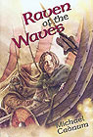 | Cadnum, Michael | RAVEN OF THE WAVES  On his first Viking raid, seventeen-year-old Lidsmod sails on the ship Raven, joining his comrades as they destroy and plunder villages in medieval England and take an Anglo-Saxon boy as captive. | 2001 | 200 p.

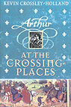 | Crossley-Holland, Kevin | AT THE CROSSING-PLACES  Arthur trilogy, volume 2  In late twelfth-century England, the thirteen-year-old Arthur goes to begin his new life as squire to Lord Stephen at Holt, where crusaders ready themselves. | 2002 | 394 p.

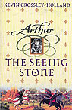 | Crossley-Holland, Kevin | SEEING STONE  Arthur trilogy, volume 1  It is 1199, and young Arthur de Caldicot is waiting impatiently to grow up and become a knight. One day, his father's friend Merlin gives him a shiny piece of obsidian, and his life becomes entwined with King Arthur's. | 2001 | 342 p.

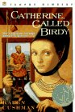 | Cushman, Karen | CATHERINE, CALLED BIRDY  The 13-year-old daughter of an English country knight keeps a journal in which she records the events of her life, particularly her longing for adventures beyond the usual role of women and her efforts to avoid being married off. | 1999 | 164 P.

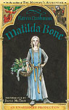 | Cushman, Karen | MATILDA BONE  Fourteen-year-old Matilda, an apprentice bonesetter and practitioner of medicine in a village in medieval England, tries to reconcile the various aspects of her life, both spiritual and practical. | 2000 | 167 p.

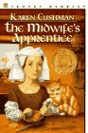 | Cushman, Karen | THE MIDWIFE’S APPRENTICE  In medieval England, a nameless, homeless girl is taken in by a sharp-tempered midwife and, in spite of obstacles and hardship, eventually gains the three things she most wants: a full belly, a contented heart, and a place in the world. | 1995 | 117 P.

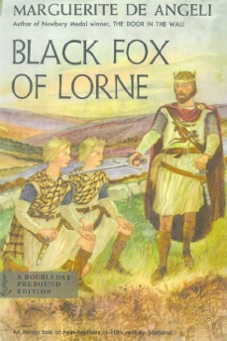 | DeAngeli, Marguerite | BLACK FOX OF LORNE  When Jan and Brus, thirteen-year-old twins emigrate with their family from Norway to 10th-century Britain, their ship is wrecked and Jan is captured by the cruel leader, the Black Fox of Lorne. | 1956 | 191 P.

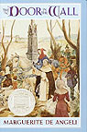 | DeAngeli, Marguerite | DOOR IN THE WALL  A crippled boy in fourteenth-century England proves his courage and earns recognition from the King. (Newbery Medal 1950) | 1949 | 120 P.

 | Ellis, Deborah | A COMPANY OF FOOLS  Henri has been living within abbey walls all his life. When Micah arrives, they form a friendship that helps them through dangerous times. | 2002 | 191 p.

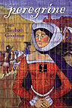 | Goodman, Joan | PEREGRINE  sequel to The Winter Hare  In 1144, fifteen-year-old Lady Edith, having lost her husband and child and anxious to avoid marrying a man she detests, sets out from her home in Surrey to go on a pilgrimage to Jerusalem. | 2000 | 222 p.

 | Goodman, Joan | THE WINTER HARE  In 1140, with England divided between the supporters of King Stephen and those of the Empress Matilda, twelve-year-old Will Belet, small for his age but longing to be a knight, comes to his Uncle's castle to be a page and soon finds himself involved in dangerous intrigues and adventures. | 1996 | 255 p.

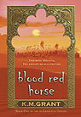 | Grant, K.M. | BLOOD RED HORSE  Book I of The de Granville trilogy  When King Richard calls for a Crusade, brothers Will and Gavin must go to the Holy Land to fight with the Knights of England. Their adventure leads them to a fair maiden named Ellie and a very special blood-red horse called Hosanna. | 2005 | 227 p.

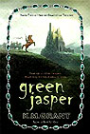 | Grant, K.M. | GREEN JASPER  Book II of The de Granville trilogy  Having returned to a politically unstable England after the Crusades, brothers Will and Gavin--with the help of the red horse Hosanna--attempt to rescue their friend Ellie who is being held prisoner by an enemy of King Richard I. | 2007 | 249 p.

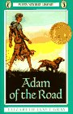 | Gray, Elizabeth Janet | ADAM OF THE ROAD  1294-1295 in and around London, England. Adam gets separated from his minstrel father while searching for his stolen dog and must make his way alone on the roads of England until he is reunited with both Roger and Nick. | 1942 | 317 P.

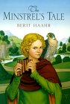 | Haahr, Berit | THE MINSTREL'S TALE  When betrothed to a repulsive man, 13-year-old Judith runs away, assumes the identity of a young boy, and hopes to join the King's Minstrels in 14th century England. | 2000 | 247 P.

 | Hendry,Frances | QUEST FOR A MAID  Aware of her older sister's powers of sorcery, which have used to help secure the Scottish throne for Robert de Brus, Meg realizes she must try protect the young Norwegian princess who has been chosen as rightful heir. | 1990 | 273 p.

 | Hunter, Mollie | THE KING'S SWIFT RIDER  Unwilling to fight but feeling a sense of duty, 16-year-old Martin joins Scotland’s rebel army as a swift rider and master of espionage for its leader, Robert the Bruce. | 1998 | 241 P.

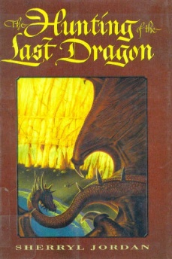 | Jordan, Sherryl | THE HUNTING OF THE LAST DRAGON  In England in 1356, as a monk records his every word, a young peasant tells of his journey with a young Chinese noblewoman to St. Alfric's Cove and the lair of a dragon . | 2002 | 186 P.

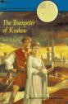 | Kelly, Eric | THE TRUMPETER OF KRAKOW  A Polish family in the Middle Ages guards a great secret treasure and a boy's memory of an earlier trumpeter of Krakow makes it possible for him to save his father. | 1928 | 208 P.

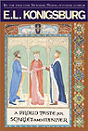 | Konigsburg, Elaine | A PROUD TASTE FOR SCARLET AND MINIVER  Eleanor of Aquitaine, wife to two kings, mother to two others, has been waiting in Heaven a long time to be reunited with her second husband. While waiting, she and three of the people who knew her well recall the events of her life. | 2001 | 201 P.

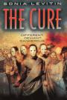 | Levitin, Sonia | THE CURE  A sixteen-year-old boy living in 2407 collides with the past when he finds himself in Strasbourg in 1348 confronting the anti-Semitism that sweeps through Europe during the Black Plague.. | 1999 | 181 P.

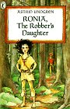 | Lindgren, Astrid | RONIA, THE ROBBER'S DAUGHTER  Ronia, who lives with her father and his band of robbers in a castle in the woods, causes trouble when she befriends the son of a rival robber chieftan. | 1983 | 176 P.

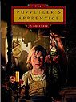 | Love, D. Anne | THE PUPPETEER'S APPRENTICE  A medieval orphan girl called Mouse gains the courage she needs to follow her dreams of becoming a puppeteer's apprentice. | 2003 | 180 p.

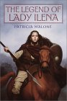 | Malone, Patricia | THE LEGEND OF LADY ILENA  In sixth-century Great Britain, a 15-year-old girl seeking knowledge of her lineage is drawn into battle to defend the homeland she never knew, aided by one of King Arthur's knights. | 2002 | 229 p.

 | McCaffrey, Anne | BLACK HORSES FOR THE KING  Galwyn, son of a Roman Celt, escapes from his tyrannical uncle and joins Lord Artos, later known as King Arthur, using his talent with languages and way with horses to help secure and care for the Libyan horses that Artos hopes to use in battle against the Saxons. | 1996 | 217 P.

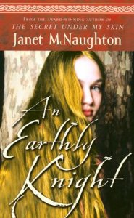 | McNaughton, Janet | AN EARTHLY KNIGHT  In 1162 in Scotland, sixteen-year-old Jenny Avenel falls in love with the mysterious Tam Lin while being courted by the king's brother and must navigate the tides of tradition and the power of ancient magic to define her own destiny. | 2004 | 261 P.

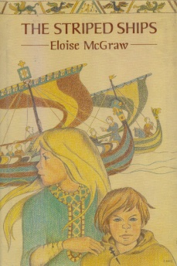 | McGraw, Eloise | THE STRIPED SHIPS  Juliana, an 11-year-old Saxon girl, loses her home and family when the Normans conquer England in 1066 and seeks to order her life by becoming involved in the creation of the Bayeux tapestry. | 1991 | 223 P.

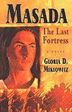 | Miklowitz, Gloria | MASADA: THE LAST FORTRESS  As the Roman army marches inexorably across the Judean desert towards the fortress of Masada, Simon and his family and friends prepare, along with the rest of the Jewish Zealots, to fight and never surrender. | 1998 | 188 P.

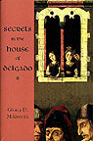 | Miklowitz, Gloria | SECRETS IN THE HOUSE OF DELGADO  In Spain in 1492, fourteen-year-old Maria, a Catholic orphan, becomes a servant to a wealthy family of Conversos, converted Jews, at a time when the Jews are being expelled from the country and when the Inquisition is diligently searching for religious heretics. | 2001 | 182 P.

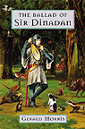 | Morris, Gerald | THE BALLAD OF SIR DINADAN  Though he would rather pursue his talent as a musician, eighteen-year-old Dinadan is forced to follow his older brother Tristram's path and become a knight. Set at the time of King Arthur. | 2003 | 232 P.

 | Morris, Gerald | PARSIFAL'S PAGE  In medieval England, eleven-year-old Piers' dream comes true when he becomes page to Parsifal, a peasant whose quest for knighthood reveals important secrets about both of their families. | 2001 | 232 P.

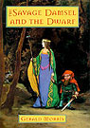 | Morris, Gerald | THE SAVAGE DAMSEL AND THE DWARF  Lynet, a feisty young woman, journeys to King Arthur's court in order to find a champion to rescue her beautiful older sister, and she is joined in her quest by a clever dwarf and a bold kitchen knave, neither of whom are not what they seem. | 2000 | 213 P.

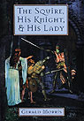 | Morris, Gerald | THE SQUIRE, HIS KNIGHT AND HIS LADY  sequel to: The Squire's Tale  After several years at King Arthur's court, Terence, as Sir Gawain's squire and friend, accompanies him on a perilous quest that tests all their skills and whose successful completion could mean certain death for Gawain. | 1999 | 232 p.

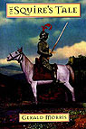 | Morris, Gerald | THE SQUIRE'S TALE  For sequel see: The squire, his knight, & his lady  In medieval England, fourteen-year-old Terence finds his tranquil existence suddenly changed when he becomes the squire of the young Gawain of Orkney and accompanies him on a long quest, proving Gawain's worth as a knight and revealing an important secret about his own true identity. | 1998 | 212 P.

 | Morressy, John | JUGGLER  Beran makes a pact with the devil to become the greatest juggler in the world. | 1996 | 261 P.

 | Paton Walsh, Jill | THE EMPEROR'S WINDING SHEET  An English boy, shipwrecked, hungry, and lost, finds his way into the court of Constantine, where he is interpreted as a symbol of good luck and is ordered to be kept always near the king. | 2004 | 251 p.

 | Picard, Barbara | RANSOME FOR A KNIGHT | 1953 | 314 P.

 | Pierce, Tamora | IN THE HAND OF THE GODDESS  Song of the Lioness, Book 2  Pursuing her desire to be a knight, Alanna learns many things in her role as squire to Prince Jonathan, but fears Duke Roger, an ambitious sorcerer with whom she knows she will one day have to deal. | 1990 | 209 P.

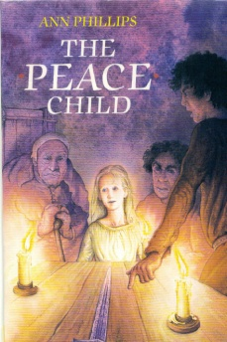 | Phillips, Ann | THE PEACE CHILD  Could the exchange of children really bring peace to feuding families? Alys can't understand her place in the family, why she must wear a white dress at certain occasions and her fair hair amongst the rest of the family's dark hair. By running away to the Castells, Alys brings an understanding and compromise between the Butlers and the Castells. 14th century England during the Peasant's Revolt and the Great Plague. | 1988 | 148 P.

 | Pope, Elizabeth | THE PERILOUS GARD  In 1558 while imprisoned at Elwenwood Hall, a remote castle in northern England, teenaged Kate Sutton finds herself involved in a series of mysterious events that eventually bring her to an underground labyrinth peopled by the last practitioners of druidic magic. | 1974 | 280 p.

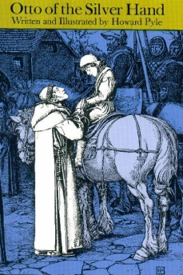 | Pyle, Howard | OTTO OF THE SILVER HAND  The gentle son of a medieval German robber baron, raised in the calm and thoughtful quiet of a monastery, returns to his father's castle and, despite great suffering and blood-feuds, grows to honor and manhood. | 1967/TD> | 170 p.

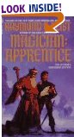 | Rosen, Sidney | THE MAGICIAN'S APPRENTICE  In 1264, Jean of Toulouse, a young French student and friar accused of heresy by the Inquisition, is sent to Oxford to spy on the scholarly monk, Roger Bacon, who is suspected of being a heretic for his advanced scientific ideas. | 1994 | 153 P.

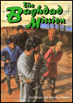 | Rosen, Sidney | THE BAGHDAD MISSION  In the year 800, 15-year-old Alan travels from the Frankish kingdom to Baghdad and back again, seeking to escape the murderour intentions of his evil cousin and secure his birthright. | 1994 | 190 p.

 | Sauerwein, Leigh | SONG FOR ELOISE  In twelth-century France, fifteen-year-old Eloise, newly and unhappily married to the rough, ambitious, much older but devoted Robert of Rochefort, finds it difficult to adjust to her new life and unwisely falls in love with the young troubadour who comes to sing at her husband's castle. | 2003 | 133 p.

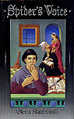 | Skurzynski, Gloria | SPIDER'S VOICE  Because he is a young mute person who can hear, Aran becomes involved in the adventures of Eloise and Abelard, France's most famous lovers, who lived during the twelfth century. | 1999 | 200 p.

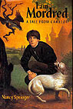 | Springer, Nancy | I AM MORDRED  A TALE FROM CAMELOT  When Mordred learns the identity of his father, he struggles with feelings of hatred, but also fights the fate which determines that he kill the good and gracious king. | 1998 | 184 P.

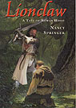 | Springer, Nancy | LIONCLAW  A TALE OF ROWAN HOOD  Young Lionel, minstrel in the outlaw band of Rowan Hood, daughter of Robin tries to find his courage when she is abducted from Sherwood Forest. | 2002 | 122 P.

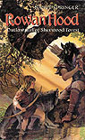 | Springer, Nancy | ROWAN HOOD  OUTLAW GIRL OF SHERWOOD FOREST  In her quest to connect with Robin Hood, the father she has never met, 13-year-old Rosemary disguises herself as a boy, befriends a half-wolf, half-dog, a runaway princess, and an overgrown boy whose singing is hypnotic, and makes peace with her elfin heritage. | 2001 | 170 p.

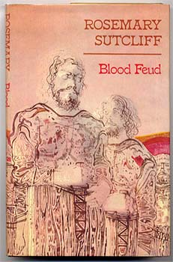 | Sutcliff, Rosemary | BLOOD FEUD  Sold into slavery to the Northmen in the tenth century, a young Englishman becomes involved in a blood feud which leads him to Constantinople and a totally different way of life. | 1977 | 144 p.

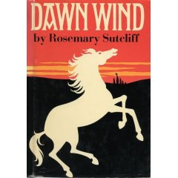 | Sutcliff, Rosemary | DAWN WIND  1. CAPRICORN BRACELET. 2. DAWN WIND. 3. EAGLE OF THE NINTH. 4. FRONTIER WOLF. 5. LANTERN BEARERS. 6. OUTCAST. Roman Britain.  closes the story of the Aquila family and Roman Britain. Opening the morning after Cealwin of Wessex defeats the British at Dyrham (about A.D. 577), and ending with the arrival of Augustine in Kent in A.D. 597 (though only fourteen years pass in the book), Dawn Wind is the story of Owain, the great-great-grandson of the main character of The Lantern Bearers. After his father and older brother are killed at Dyrham, Owain must find his way in a land that is no longer Britain but isn't quite England. With Cealwin's victory, Britain is all but gone. Only Cornwall, Wales, and Strathclyde are free of the invaders. With nothing left, Owain hits on the idea of crossing to still-free Brittany, but the hopelessness of the task for a fourteen-year-old boy defeats him. To save the life of a British girl he found in the ruins of his home city, Owain sells himself into thralldom. He grows to adulthood on a Saxon farm, gaining an understanding of their culture that none of his ancestors had. Owain finds acceptance and freedom with the Saxons, but in the end he still identifies with the British. His return to the hills of Wales after the arrival of Christian missionaries to the Kentish kingdom completes the transformation of the Aquila family from Roman to British. | 1961 | 241 p.

 | Sutcliff, Rosemary | THE LANTERN BEARERS  Roman times and the Middle Ages in Britain and Juteland. When the Roman legions leave Britain, the light of civilization is quenched. Aquila and his family are separated through the violence of Saxon invaders. After many years of suffering come reconciliation and a promise of an end of darkness through the leader Ambrosius and young Artos. | 1959 | 252 P.

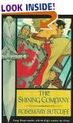 | Sutcliff, Rosemary | THE SHINING COMPANY  600 A.D. Prosper tries to save a white hart from a hunting party led by Prince Gorthyn who admires his daring. Two years later Prosper joins forces with the prince to fight the invading Saxons. For a year they train. While trying to capture the stronghold at Catraeth treachery stikes from a most unexpected source. | 1990 | 293 P.

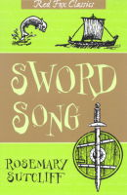 | Sutcliff, Rosemary | SWORD SONG  In this swashbuckling epic, a Viking swordsman is banished from his home for unintentionally killing a man and takes up a new life as a mercenary. | 1998 | 271 P.

 | Temple, Frances | THE BEDUINS' GAZELLE  sequel to The Ramsay Scallop  In 1302, 2 cousins of the nomadic Beni Khalid tribe who are bethrothed become separated by poltical intrigue between warring tribes.TD> | 1956 | 159 P.

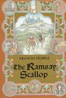 | Temple, Frances | THE RAMSAY SCALLOP  In 1299 England, 14-year-old Elenor finds her betrothal to an ambitious lord's son launching her on a memorable pilgrimage to far-off Spain. | 1994 | 310 P.

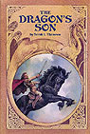 | Thomson, Sarah | THE DRAGON'S SON  Based on the Mabinogion, a collection of medieval Welsh tales, as well as later legends, and tells of family members and servants important in the life of King Arthur, featuring Nimue, Morgan le Fay, Luned, and Mordred. | 2001 | 181 p.

