THE FARM SUMMER 1942  A young boy spends the summer on his grandparents' farm in New Hampshire while his mother works in the war effort in New York and his father serves on a destroyer in the Pacific. | 1994 | unpaged

 | Helmer, Marilyn | ONE SPLENDID TREE  With Daddy off fighting in the Second World War, Momma has to take a factory job and money is tight. But ingenuity and determination to provide a Christmas tree for his family drives a young boy to perform some Christmas magic. | 2005 | 32 p.

 | Hoobler, Thomas | ALOHA MEANS COME BACK  THE STORY OF A WORLD WAR II GIRL  Laura and her mother join her Navy father in Hawaii in 1941, where suspicion against the Japanese American residents runs high in an atmosphere of expectation that the United States and Japan will go to war. | 1991 | 51 p.

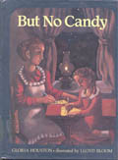 | Houston, Gloria | BUT NO CANDY  THE STORY OF A WORLD WAR II GIRL  While her Uncle Ted is off fighting in World War II, Lee watches the candy gradually disappear from the shelves of her family's store and realizes that her entire world has changed. | 1992 | unpaged

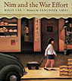 | Lee, Milly | NIM AND THE WAR EFFORT  In her determination to prove that an American can win the contest for the war effort, Nim does something which leaves her Chinese grandfather both bewildered and proud. | 1997 | 40 p.

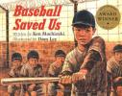 | Mochizuki, Ken | BASEBALL SAVED US  A Japanese American boy learns to play baseball when he and his family are forced to live in an internment camp during World War II, and his ability to play helps him after the war is over. | 1993 | unpaged

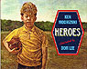 | Mochizuki, Ken | HEROES  Japanese-American Donnie, whose playmates insist he be the "bad guy" in their war games, calls on his reluctant father and uncle to help him get away from that role. | 1995 | 32 p.

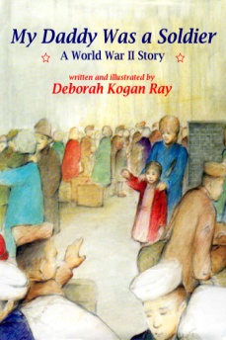 | Ray, Deborah | MY DADDY WAS A SOLDIER  While Daddy's away fighting in the Pacific, Jeannie plants a Victory garden, collects scrap, and sends letters to her father as she anxiously awaits his return. | 1990 | unpaged

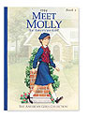 | Tripp, Valerie | MEET MOLLY: AN AMERICAN GIRL  1944. While her father is away fighting in World War II, Molly finds her life full of change as she eats terrible vegetables from the victory garden and plans revenge on her brother for ruining Halloween. | 1989 | 52 p.

 | Tripp, Valerie | MOLLY AND THE MOVIE STAR  American Girls Short Stories  Molly is eager to meet a famous movie star at a War Bond rally, until she cannot find the money that her class had collected to buy a bond. Includes information on movies during World War II and a recipe for popcorn. | 2000 | 40 p.

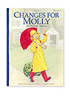 | Tripp, Valerie | CHANGES FOR MOLLY  A WINTER STORY  Molly McIntire and her friends, Linda and Susan, are trying out to be Miss Victory, in their big dance program. Molly practices every day, and thinks she has a pretty good chance for the most important part. She is worried that she won't look pretty with her hair "as straight as sticks". Linda and Susan have an idea to help Molly. They put their money together to buy a home permanent. The girls hide out in Molly's garage to begin the perm. Molly finds out at the last minute, her friend Susan doesn't really know how to roll a perm. She has seen someone with a perm before, but it couldn't be that hard. Molly's family gets news that her father will be coming home from the war. This makes Molly even more determined to get the part of Miss Victory, and to show her father how grown-up she has become, while he was away. | 1988 | 67 p.

 | Tripp, Valerie | HAPPY BIRTHDAY, MOLLY!  A SPRINGTIME STORY  When an English girl comes to stay at Molly's during World War II, she and Molly learn to bridge their differences and ultimately enjoy a wonderful, mutual birthday party. | 1989 | 57 p.

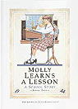 | Tripp, Valerie | MOLLY LEARNS A LESSON  Molly is determined that the third-grade girls will win her school's Lend-a-Hand Contest to help the war effort. When they choose an idea that Molly knows will never work, she talks two friends into doing their own secret project. But the project turns out to be harder than Molly expected. Worried that it might not win after all, Molly decides to spy on the other girls to see how they are doing. When Molly and her friends get caught peeking in a window, they learn some important lessons. | 1990 | 58 p.

 | Tripp, Valerie | MOLLY MARCHES ONE  American Girls Short Stories  Molly wants to be the first to find a surprise at the end of the nature hike at her camp. When she ventures off the trail, she finds a secret surprise of her own. | 2001 | 40 p.

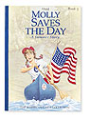 | Tripp, Valerie | MOLLY SAVES THE DAY  A SUMMER STORY  Molly conquers her fear of swimming underwater when she and the other campers at Camp Gowonagin divide into two teams to play Color War. | 1988 | 69 p.

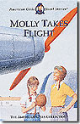 | Tripp, Valerie | MOLLY TAKES FLIGHT  American Girls Short Stories  Molly feels that everything in her life has changed when her father goes off to England to help wounded soldiers and her beloved aunt joins the Women's Airforce Service pilots. Includes a section on women pilots in the armed services, and a project related to the story. | 1999 | 40 p.

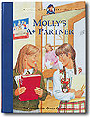 | Tripp, Valerie | MOLLY'S A+ PARTNER  American Girls Short StoriesMolly and Susan pair up to write a report about George Washington. When they disagree about how to present the report, Molly thinks their grade--and their friendship--might be doomed. | 2002 | 48 p.

 | Tripp, Valerie | MOLLY'S PUPPY TALE  American Girls Short StoriesIn 1945, ten-year-old Molly does not want to share her puppy Bennett with her brother but finds she might need to change her mind. | 2003 | 40 p.

 | Tripp, Valerie | MOLLY'S SURPRISE  A CHRISTMAS STORY  Even though he is away serving in an English hospital during World War II, Molly's father finds a way to make the family Christmas very special. | 1986 | 64 p.

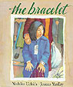 | Uchida, Yoshiko | THE BRACELET  Emil, a Japanese American in the second grade, is sent with her family to an internment camp during World War II, but the loss of the bracelet her best friend has given her proves that she does not need a physical reminder of that friendship. | 1993 | unpaged

5th Grade and Up
 | Aaron, Chester | ALEX, WHO WON HIS WAR  Nazi espionage agents threaten to kill two helpless women if Alex doesn't help with their sabotage plans in Connecticut. Concern for the fate of his brother during the final months of World War II adds to Alex's anguish. | 1991 | 156 p.

 | Buckey, Sarah | THE LIGHT IN THE CELLAR  A Molly Mystery  American Girl  Molly wishes she and her friend Emily had an exciting volunteer job that really helped in the fight to win World War Two. Instead, they're magazine delivery girls at Oak Knoll Hospital. Soon, however, Molly and Emily start to suspect that something very un-patriotic is going on at Oak Knoll--and their snooping leads them deep into trouble! | 2007 | 162 p.

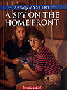 | Hart, Alison | A SPY ON THE HOMEFRONT  A Molly Mystery  American Girl  During a two-week stay at Grammy and Granpa's farm in the summer of 1944, Molly spends lots of time with her good friend Anna Schulz, the daughter of German immigrants who live on a neighboring farm. When Aunt Eleanor, now a WASP pilot, stops for a visit while ferrying a warplane from one airbase to another, a security check uncovers anti-American propaganda stashed aboard her plane. The FBI interrogates Eleanor but quickly zeroes in on another suspect--Anna's 17-year-old brother Max, who works at the local airfield. Though Anna knows her brother is loyal to America, she fears he'll be sent away to an interment camp as an enemy alien, as other German-American friends have been. Molly and Anna decide that the only way to clear Max is to find the person who is smuggling propaganda. With lots of daring and a little luck, the girls manage to finger the real culprit…but they discover that that may not be enough to save Max. In a poignant ending, Molly realizes that wartime, even on the home front, changes friends and family forever. | 2005 | 165 p.

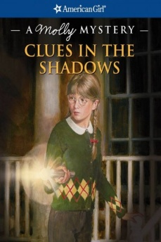 | Ernst, Kathleen | CLUES IN THE SHADOWS  A Molly Mystery  American Girl  As the war continues into May 1945, eleven-year-old Molly finds herself pulled in many different directions trying to cope with her troubled father's return from war, the abrupt resignation of her favorite Red Cross volunteer, a scrap-paper drive, and a mysterious neighborhood prowler. | 2009 | 179 p.

 | Avi | WHO WAS THAT MASKED MAN, ANYWAY?  In the mid-forties when nearly everyone else is thinking about World War II, 6th grader Frankie Wattleson gets in trouble at home and at school because of his preoccupation with his favorite radio programs. | 1992 | 170 p.

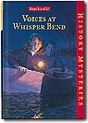 | Ayers, Katherine | VOICES AT WHISPER BEND  American Girl History Mysteries  In their Pennsylvania town in 1942, 12-year-old Charlotte and her classmates collect scrap metal for the war effort only to have it disappear from the school basement. | 1999 | 155 p.

 | Banks, Sara | UNDER THE SHADOW OF WINGS  During 1944, life in rural Alabama brings changes for 11-year-old Tattnall as she realizes that she cannot always protect her older, brain-damaged cousin. | 1997 | 207 p.

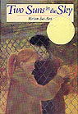 | Bat-Ami, Miriam | TWO SUNS IN THE SKY  Oswego, NY, June 1944-February 1946. Chris's father orders her to stay away from a shelter for war refugees, but she meets Adam Bornstein an Yugoslavian Jew. Adam has escaped from Zagreb to Rome to America with his mother and sister. An attraction grows between Adam and Chris and an understanding of others. | 1999 | 223 p.

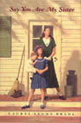 | Brady, Laurel | SAY YOU ARE MY SISTER  In rural Georgia during World War II, 12-year-old Ramona Louise determines to do everything to help her beloved older sister Georgie keep the family together after the death of their parents, even to keeping a secret which could destroy their close relationship. | 2001 | 208 p.

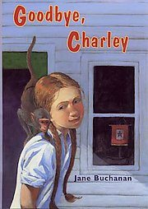 | Buchanan, Jane | GOODBYE, CHARLIE  In 1943, 12-year-old Celie's father brings home a rhesus monkey that helps Celie deal with all the difficulties that the war has brought into her life in Gloucester, Massachusetts. | 2004 | 165 p.

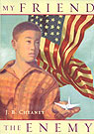 | Cheaney, J.B. | MY FRIEND THE ENEMY  During World War Ii, a twelve-year-old girl becomes friends with a young Japanese-American boy she discovers being sheltered and hidden by her neighbor. | 2005 | 262 p.

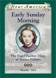 | Deneberg, Barry | EARLY SUNDAY MORNING  The Pearl Harbor Diary of Amber Billows. Hawaii 1941  Dear America  A move from Washington, D.C. finds the Billows family residing on Oahu, when Pearl Harbor is attacked. 12 year-old Amber cannot believe that she has to move again since she moved 4 times in the last few years. Her father is a reporter, her mom is a stay-at-home mom who likes to cook, and her brother is a baseball maniac. When she arrives in Hawaii, she likes it. She meets a new friend called Kame, who is Japanese. They become good friends. After the Japanese bomb Pearl Harbor, the police take Kame's father into custody. | 2001 | 129 p.

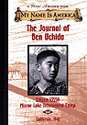 | Deneberg, Barry | THE JOURNAL OF BEN UCHIDA, CITIZEN 13599, MIRROR LAKE INTERNMENT CAMP  My Name is America  12-year-old Ben Uchida keeps a journal of his experiences as a prisoner in a Japanese internment camp in Mirror Lake, California, during World War II. | 1999 | 156 p.

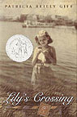 | Giff, Patricia Reilly | LILY'S CROSSING  During a summer spent at Rockaway Beach in 1944, Lily's friendship with a young Hungarian refugee causes her to see the war and her own world differently. | 1997 | 180 p.

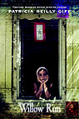 | Giff, Patricia Reilly | WILLOW RUN  During World War II, Meggie moves with her parents to Willow Run, Michigan, because her father gets a job in the B-24 bomber-building factory. Eleven-year-old Meggie learns about different kinds of bravery from all of the people around her. | 2005 | 149 p.

 | Glassman, Judy | THE MORNING GLORY WAR  While corresponding with a young serviceman fighting overseas during World War II, Jeannie Newman is promised that if she takes good care of the morning glory seeds in a window box, she can have a victory garden, but disaster threatens her dreams. | 1990 | 119 p.

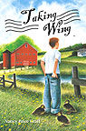 | Graff, Nancy | TAKING WING  In the days after the U.S. entered WWII, thirteen-year-old Gus spends his time on his grandparents' farm in Vermont. Meanwhile, his father trains as an air force pilot and his mother recuperates from tuberculosis in a distant town. | 2005 | 211 p.

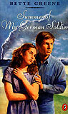 | Greene, Bette | SUMMER OF MY GERMAN SOLDIER  When her small hometown in Arkansas becomes the site of a camp housing German prisoners during World War II, 12-year-old Patty Bergen learns what it means to open her heart. | 1973 | 230 p.

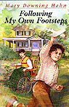 | Hahn, Mary Downing | FOLLOWING MY OWN FOOTSTEPS  In 1945, Gordy's grandmother takes him and his family into her North Carolina home after his abusive father is arrested, and he just begins to respond to his grandmother's loving discipline when his father returns. Companion story to Stepping on the Cracks. | 1996 | 186 p.

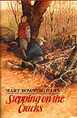 | Hahn, Mary Downing | STEPPING ON THE CRACKS  In 1944, while her brother is overseas fighting in World War II, 11-year-old Margaret gets a new view of the school bully Gordy when she finds him hiding his own brother, an army deserter, and decides to help him. | 1991 | 216 p.

 | Hermes, Patricia | SWEET BY and BY  11-year-old Blessing has lived with her grandmother in a cabin in the Tennessee mountains since she was two years old, secure in a relationship of love and shared music, but now she has to accept that her grandmother is dying and the must continue life without her in a new home. | 2002 | 192 p.

 | Hinman, Bonnie | JENNIE'S WAR  Sisters in Timeseries  The Home Front in World War II  In 1944, ten-year-old Jennie Fleming is doing what she can to help win the war - she's hoeing weeds in her "Victory Garden" on the "home front." | 2005 | 138 p.

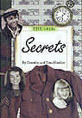 | Hoobler, Dorothy | Secrets  1940's  When 10-year-old Abby Carter attends the newly established school for the blind in Boston in 1832, she proves that blind people can learn and be independent. | 1998 | 160 p.

 | Hopper, Nancy | CASSANDRA - LIVE AT CARNEGIE HALL  Moving with her parents and younger sister from Connecticut to her father's studio in Carnegie hall during World War II is difficult for 13-year- old Cassandra. 1944 New York City. | 1998 | 151 p.

 | Hostetter, Joyce Moyer | BLUE  With her father away at war to fight Hitler, a young girl gains strength by joining her community in battling polio in this story based on the 1944 epidemic and the "Miracle of Hickory" Hospital in Hickory, North Carolina. Ann Fay Honeycutt accepts the role of "man of the house" when her father leaves because she wants to do her part for the war. She's doing well with the extra responsibilities when a frightening polio epidemic strikes, crippling many local children. Her town of Hickory responds by creating an emergency hospital in three days. Ann Fay reads each issue of the newspaper for the latest news of the epidemic. But soon she discovers for herself just how devastating polio can be. As her challenges grow, so does her resourcefulness. In the face of tragedy, Ann Fay discovers her ability to move forward. She experiences the healing qualities of friendship and explores the depths of her own faithfulness to those she loves—even to one she never expected to love at all. | 2006 | 197 p.

 | Kadohata, Cynthia | WEEDFLOWER  After twelve-year-old Sumiko and her Japanese-American family are relocated to an internment camp on a Mojave Indian reservation in Arizona, she struggles to become friends with a Mohave boy and to find her place in the world. | 2006 | 257 p.

 | Kerr, M.E | SLAP YOUR SIDES  Life in their Pennsylvania hometown changes for Jubal Shoemaker and his family when his older brother witnesses to his Quaker beliefs by becoming a conscientious objector during World War II. | 2001 | 198 p.

 | Lisle, Janet Taylor | THE ART OF KEEPING COOL  In 1942, Robert and his cousin Elliot uncover long-hidden family secrets while staying in their grandparents' Rhode Island town, where they also become involved with a German artist who is suspected of being a spy. | 2000 | 207 p.

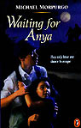 | Morpurgo, Michael | WAITING FOR ANYA  Jo lives in a village on the French/Spanish border in the Pyrenees mountains during the German occupation of France in the Second World War. Early on the meets Benjamin, a man trying to smuggle Jewish children across to safety in Spain. Benjamin was separated from his daughter Anya when they fled Paris, but hopes that one day she will find her way to the cottage. German soldiers soon occupy the village and the people are warned anyone helping Jews across the border will be shot. Jo continues to help Benjamin in absolute secrecy, despite the danger. Together they have to find another way to get the children into Spain, and risk everything to ask the whole village to join in the plan. Just a few days later, the war ends, and Benjamin's daughter Anya, finally, comes home to the mountain cottage. | 1990 | 172 p.

 | Osborne, Mary Pope | MY SECRET WAR  THE WORLD WAR II DIARY OF MADELINE BECK  DEAR AMERICA  13-year-old Madeline's diaries for 1941 and 1942 reveal her experiences living on Long Island during World War II while her father is away in the Navy. | 2000 | 158 p.

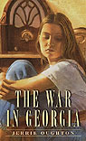 | Oughton, Jerrie | THE WAR IN GEORGIA  Living in Georgia during World War II, 13-year-old Shanta sometimes feels that her family and neighborhood are more hopeless battlefields than those in foreign lands. | 1997 | 181 p.

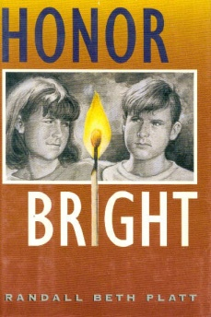 | Platt, Randall | HONOR BRIGHT  While visiting her grandmother during the summer of 1944, a 14- year-old girl helps to heal the wounds that have been inflicted upon three generations of women. | 1997 | 229 p.

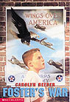 | Reeder, Carolyn | FOSTER'S WAR  When his older brother joins the army during World War II in order to escape the rages of an authoritarian father, 11-year-old Foster fights his battles on the home front. | 1998 | 267 p.

 | Rinaldi, Ann | KEEP SMILING THROUGH  A 10-year-old girl living in middle-class America during World War II learns the painful lesson that doing what's right is not always an easy thing to do. | 1996 | 188 p.

 | Salisbury, Graham | UNDER THE BLOOD-RED SUN  Tomikazu Nakaji's biggest concerns are baseball, homework, and a local bully, until life with his Japanese family in Hawaii changes drastically after the bombing of Pearl Harbor in December 1941. | 1994 | 246 p.

 | Savin, Marcia | THE MOON BRIDGE  The friendship between San Francisco girls Mitzi Fujimoto and Ruthie Fox is changed when World War II begins and Mitzi and her family are forced to got into an internment camp. | 1992 | 225 p.

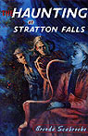 | Seabrooke, Brenda | THE HAUNTING AT STRATTON FALLS  At Christmastime in 1944, while staying with disagreeable cousins in New York State because her father is in Europe fighting in World War II, 11-year-old Abby discovers that her relatives' old house is haunted by the ghost of a girl from the Civil War era. | 2000 | 151 p.

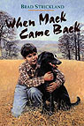 | Strickland, Brad | WHEN MACK CAME BACK  When his older brother Ben leaves the family farm in order to join the army in 1943, 10-year-old Maury remains behind to deal with his angry father and to care for Ben's injured puppy. | 1992 | 225 p.

 | Talbert, Marc | STAR OF LUIS  Just after the bombing of Pearl Harbor, a Mexican American boy goes with his mother from Los Angeles to New Mexico to meet her family for the first time, and , while there, he discovers his family’s hidden Jewish heritage. | 1999 | 173 p.

 | Weston, Elise | THE COASTWATCHER  While 11-year-old Hugh, his family and his cousin Tom are spending the summer of 1943 on the South Carolina shore to ecape the polio epidemic, Hugh uncovers clues that point to a German plot to sabotage a nearby naval base. | 2005 | 123 p.

 | Willis, Patricia | A PLACE TO CLAIM AS HOME  13-year-old Henry, hired by the strangely unfriendly Miss Morrison to be summer help on her farm in 1943 while most of the men in the area are overseas in the war, discovers that her gruff hardness conceals hurt over a secret in her past. | 1991 | 166 p.

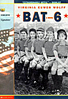 | Wolff, Virginia | BAT 6  This powerful novel about racial prejudice in post-World War II America pits two Oregon farming communities against each other on the softball field. The story offers a new knowledge of the consequences of war and the need for peace. | 2000 | 230 p.

 | Zindel, Paul | GADGET  In 1945, having joined his father at Los Alamos, where he and other scientists are working on a secret project to end World War II, thirteen-year-old Stephen becomes caught in a web of secrecy and intrigue. | 2001 | 104 p.

